Technical Proposal
EUAS Midnight Modules - WordPress/WooCommerce Engineering Delivery
Date: 06 March 2026

Project | EUAS Midnight Modules Delivery
Document purpose | Technical approach, methodology, deliverables, and QA plan (no financials).

1. Introduction
This proposal describes how we will deliver EUAS “midnight modules” on a WordPress/WooCommerce platform. It outlines the technical approach, development methodology, deliverables, quality assurance practices, and a recommended technology stack for development from scratch and ongoing module delivery.

2. Project Understanding
Based on the provided EUAS Midnight Modules Orientation v0.1, the key context is:
- EUAS is a founder-built WordPress + WooCommerce e-commerce platform focused on a clean, high-trust user experience.
- Work is executed as small, clearly defined “midnight modules” that can be delivered independently.
- Each module has a fixed scope, fixed bid, and includes acceptance tests.
- Core tools include WordPress, WooCommerce, Elementor Pro, and Advanced Custom Fields (ACF).
- Custom code is used only where required and should remain minimal and maintainable.
- Delivery expects fast turnaround, simple handover, and lightweight communication (no heavy PM overhead).

3. Objectives
- Deliver self-contained engineering modules with predictable scope, timeline, and acceptance tests.
- Maintain a stable WordPress/WooCommerce foundation with strong performance and security hygiene.
- Ensure every module is production-ready: tested, documented, and deployable through a controlled release process.
- Enable EUAS to continue building in-house with clear handover and maintainable code.

4. Scope of Work

4.1 In Scope
- Environment setup for module development (local, staging, production), source control, and deployment pipeline.
- Implementation of EUAS midnight modules (theme tweaks, WooCommerce configuration, Elementor templates, ACF field groups, and small custom plugins/snippets as needed).
- Acceptance testing per module, regression testing, and deployment validation.
- Developer documentation and handover notes per module.

4.2 Out of Scope
- Financial proposal, pricing, and commercial terms (explicitly excluded).
- Large-scale re-platforming away from WordPress/WooCommerce.
- Ongoing 24/7 managed hosting support (can be added as a separate support agreement).
- Major UI/UX redesign beyond what is required for a given module.

5. Proposed Technical Approach

5.1 Principles
- Prefer configuration over customization (use WooCommerce/Elementor/ACF capabilities first).
- Keep custom code minimal, isolated, and version-controlled (small plugins over theme hacks).
- Follow WordPress coding standards and security practices (validation, sanitization, escaping, and nonces).
- Treat each module as a releasable unit with its own Definition of Done (DoD) and acceptance tests.

5.2 Midnight Module Delivery Model
Each module will be delivered as a mini-project with a short, repeatable workflow. This keeps risk low, enables fixed-bid quoting, and supports rapid iteration.
- Module Brief & Scope Freeze (what will be built, assumptions, acceptance tests)
- Solution Design Note (approach, data points, hooks/plugins affected)
- Implementation (configuration + code changes)
- QA & Acceptance Testing (module tests + regression)
- Test Support and Release to Production
- Handover (release notes + how-to + rollback plan)

5.3 Module Implementation Standards
- No core edits: do not modify WordPress or WooCommerce core files.
- Prefer site-specific plugin(s) for custom PHP to keep changes portable across themes.
- Use hooks, filters, and WooCommerce APIs for extensibility and upgrade safety.
- Store ACF field groups in code using Local JSON (where applicable) to support versioning and review.
- Keep Elementor templates structured and documented (template naming convention + where used).

6. Development Methodology

6.1 Agile Micro-Iterations
We will use a lightweight agile approach tailored for small modules: short cycles, fixed scope, daily async updates, and fast review/approval. Each module proceeds only after scope freeze.

6.2 Version Control and Branching
- Git repository for all custom code, configuration exports (where possible), and deployment scripts.
- Branch-per-module strategy (feature branch -> staging -> production).
- Pull request review and checklist-based approvals before merging.

6.3 Documentation-First Handover
- Every module includes a short README: what changed, how to use, and how to rollback.
- Admin/user steps recorded as simple checklists (screenshot placeholders included).

7. Proposed Technical Stack
The following stack is recommended to align with current WordPress and WooCommerce requirements and best practices:

7.1 Core Platform
- CMS: WordPress
- E-commerce: WooCommerce
- Page Builder: Elementor Pro (for layout and templates).
- Content Modeling: Advanced Custom Fields (ACF) for structured content blocks.

7.2 Infrastructure and Runtime
- Runtime: PHP 8.3+ (recommended).
- Database: MySQL 8.0+ or MariaDB 10.6+ (recommended).
- Web Server: Nginx or Apache with HTTPS/TLS enabled.
- Caching: Page cache + object cache (Redis recommended) and a CDN where applicable.
- Storage: Local or S3-compatible object storage for media backups (optional).

7.3 Engineering Tooling
- Local development: Docker-based setup (PHP + MySQL/MariaDB) or LocalWP equivalent.
- Code quality: PHP_CodeSniffer with WordPress Coding Standards (WPCS).
- Automation: WP-CLI for scripted tasks (database sync, plugin activation, cache flush).
- CI/CD: GitHub Actions (or equivalent) for linting, tests, and controlled deployments.
- Observability: server + application logs, uptime monitoring, and error tracking (e.g., Sentry) as needed.

8. Architecture Overview and Diagrams

8.1 High-Level Solution Architecture
Figure 1: High-Level WordPress/WooCommerce Architecture
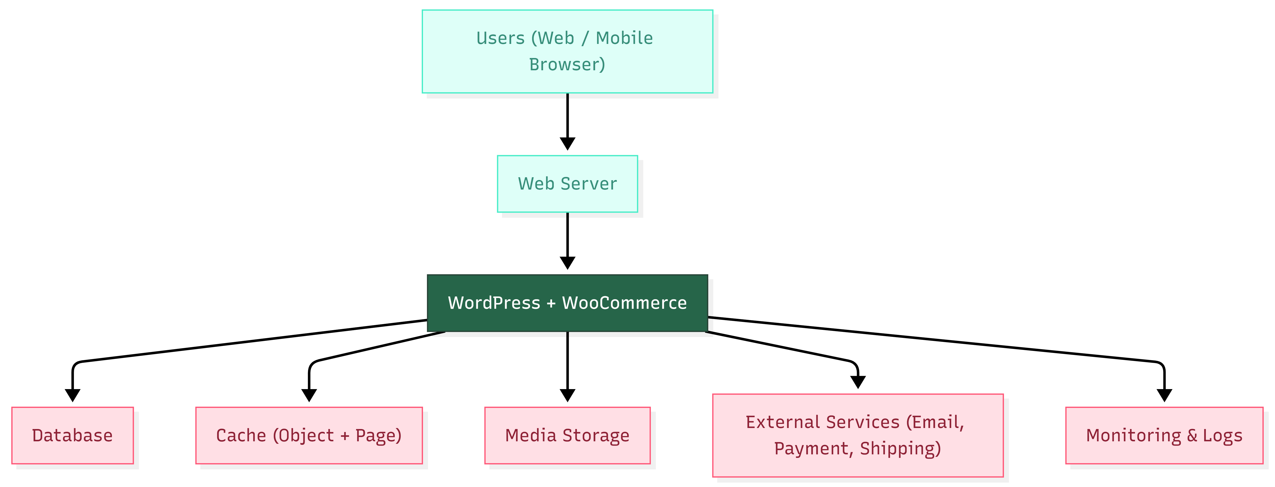

9. Deliverables

9.1 Deliverables Per Module
Each midnight module will include the following deliverables as a minimum:
Deliverable | Description | Acceptance Evidence
Module Brief (Scope + Assumptions) | Short scope statement, boundaries, dependencies, and acceptance tests. | Approved scope document / email.
Solution Design Note | Implementation approach, impacted WP components (plugins, templates, hooks), data model notes. | Design note attached to PR or shared doc.
Implementation | Elementor/ACF configuration exports (where possible) + custom code (plugin/snippet) + config changes. | Merged PR / deployed artifact.
Test Pack | Module acceptance tests + regression checklist relevant to impacted flows. | Completed checklist and test evidence.
Release Notes | What changed, migration steps, feature toggles, and rollback plan. | Release note document.
Handover Guide | How admins use the feature; where settings are; troubleshooting tips. | Handover doc with steps.

9.2 Platform-Level Deliverables (Initial Setup)
- Development, staging, and production environment setup (or alignment with existing hosting).
- Git repository initialization and branching conventions.
- Baseline security hardening checklist and plugin governance rules.
- QA strategy and regression checklist baseline for EUAS store.
- Deployment runbook (backup, deploy, verification, rollback).

10. Testing and Quality Assurance

10.1 Quality Gates
- Scope and acceptance tests are approved before development starts.
- Code follows WordPress coding standards; linting passes (PHPCS/WPCS).
- No critical security issues: input validated/sanitized; output escaped; nonces used for forms/actions.
- Acceptance tests executed and documented; relevant regressions re-tested.
- Release notes, rollback plan, and handover guide completed.
- Deployment verified on staging and production (smoke test).



11. Security, Privacy, and Reliability

11.1 WordPress Security Baselines
- Validate, sanitize, and escape all custom inputs/outputs; enforce least-privilege capabilities for admin actions.
- Use WordPress nonces to protect custom forms and state-changing requests (CSRF protection).
- Minimize plugin footprint and keep WordPress, themes, and plugins updated (supply-chain hygiene).
- Apply backups, monitoring, and incident-friendly logging to support recovery.

11.2 OWASP-Aligned Risk Considerations
Security practices will be aligned with OWASP Top 10 (latest edition) as a practical baseline for common web risks such as broken access control, security misconfiguration, supply chain failures, and injection.

11.3 Reliability and Rollback
- Pre-deploy backups (database + files) and a documented rollback plan per module.
- Feature toggles or safe fallbacks where a module impacts critical checkout flows.
- Post-deploy smoke tests and monitoring review.

12. Deployment and Operations

12.1 Environments
- Local: developer environment for rapid iteration and debugging.
- Staging: production-like environment for QA, using a sanitized copy of production data where possible.
- Production: live site with restricted access, backups, caching, and monitoring enabled.

12.2 Deployment Runbook (Per Module)
- Pre-deploy: backup, maintenance window confirmation (if needed), cache warm-up plan.
- Deploy: apply code/config changes, run DB migrations or settings updates (if applicable).
- Verify: smoke test critical flows (homepage, product page, cart, checkout, payment, emails).
- Post-deploy: monitor logs/alerts, confirm analytics and payment events, document release.

12.3 Monitoring and Maintenance (Recommended)
- Uptime monitoring and alerting for critical endpoints (homepage, checkout).
- Centralized error monitoring for PHP/JS issues (optional).
- Security patch routine for WordPress core and plugins with a staging-first approach.

13. Communication and Governance

13.1 Communication Cadence
- Kick-off per module: confirm scope, acceptance tests, and access.
- Daily async update (short message: progress, blockers, next step).
- Review checkpoint: demo on staging + sign-off before production release.

13.2 Access and Permissions
- Principle of least privilege for admin accounts and server access.
- Separate credentials per environment; rotate keys when team members change.
- All changes tracked through version control and deployment logs.

14. Assumptions and Dependencies
- EUAS will provide access to hosting/admin panels and required premium plugins (Elementor Pro, ACF) licenses.
- A staging environment will be available (or will be set up as part of initial deliverables).
- Payment/shipping providers and credentials will be provided for integration testing.
- Content and product data required for testing will be available (or mock data will be approved).

15. Key Risks and Mitigations
Risk | Impact | Mitigation
Plugin conflict or upgrade regression | Site breakage or checkout issues | Staging-first updates, regression checklist, rollback plan.
Scope creep within a fixed-bid module | Schedule slip and rework | Scope freeze; changes handled as a new module or change request.
Performance degradation from heavy builders/plugins | Slow pages and reduced conversion | Use caching/CDN; minimize plugins; performance checks per module.
Security vulnerabilities in third-party plugins | Data exposure or compromise | Plugin governance, timely updates, least privilege, OWASP-aligned checks.
Limited test data or credentials | Inadequate test confidence | Use sandbox credentials and agreed mock data; validate end-to-end on staging.

16. Acceptance Criteria
A module is considered accepted when:
- All agreed acceptance tests pass on staging and (after release) on production.
- No Priority-1 defects remain open.
- Handover documentation and release notes are delivered.
- EUAS confirms sign-off (email or ticket confirmation).

